Progress Report for October 2022
Figure 3. Variation of the porosity within the same (6CP) specimen.

A vision-based approach for robotic manufacturing

Project Objectives:
- The development of STRATA R&D MMO-500 robot to the qualification requirements.
- The development of the robotic deburring end-effector to the industrial specifications of STRATA.
- The development of a robotic painting end-effector for the inner-surface of drilled holes.
- The development of a robotic riveting end-effector.
- The development of a counter-sink inspection capability for the robotic machining platform.
- The research on dynamic vision optical sensing, as per our patent application 2020-034.
- The research on vision-based navigation to supplement the LiDAR system currently in use.
- The research on the integration of dynamic vision and light coding technology for faster surface inspection.
- The training of national Khalifa University students on robotic manufacturing technologies, including the mathematical fundamentals, robotic perception, mechanical design and the operation of robots in the industry.
Cumulative and new project outputs regarding publications and IP.
- Publication and IP updates in October:
  - Our article titled “ConvMixer-based Unet for Segmentation Refinement of Unknown Objects in Cluttered Scenes” has been re-submitted to “IEEE Access” after addressing the reviewer’s questions and concerns of the first round for review.
  - Our article titled “A Novel Vision-based Multi-functional Sensor for Normality
and Position Measurements in Precise Robotic Manufacturing” has been submitted to the “Journal of Intelligent Manufacturing”.
  - Our SWARD proposal has received been chosen for funding by Sandooq Al Watan.

- Summary of IP during 2022:
  - 3 accepted and published articles:
    - “Real-Time Grasping Strategies Using Event Camera”
    - “Neuromorphic Vision Based Control for the Precise Positioning of Robotic Drilling Systems”
    - “Neuromorphic Camera Denoising using Graph Neural Network-driven Transformers”
  - 3 articles under review:
    - “ConvMixer-based Unet for Segmentation Refinement of Unknown Objects in Cluttered Scenes”
    - “A Novel Vision-based Multi-functional Sensor for Normality
and Position Measurements in Precise Robotic Manufacturing”
  - 4 articles in progress:
    - “FEA-based simulation of visuotactile sensors”
    - “Multi-purpose autonomous robotic machining platform”
    - “Neuromorphic vision based Countersink Inspection”
    - “Neuromorphic vision based segmentation dataset”
  - 1 grant proposal submitted to Sandooq Al watan’s SWARD has been accepted for funding.
  - 1 patent under review

2022 Project KPI Summary
- Targets (as indicated in Statement of Work)
- The publication of three journal articles
- The development of two industrial prototypes (one for STRATA and another for SANAD)
- The training of 6-8 undergraduate students
- Achievements
- Three accepted/published articles:
  - “Real-Time Grasping Strategies Using Event Camera” published in “Journal of Intelligent Manufacturing”.
  - “Neuromorphic Vision Based Control for the Precise Positioning of Robotic Drilling Systems” accepted for publication at “Robotics and Computed-Integrated Manufacturing”
  - “Neuromorphic Camera Denoising using Graph Neural Network-driven Transformers” accepted at the IEEE transactions on Neural Networks and Learning Systems.

- Two articles under review:
  - “ConvMixer-based Unet for Segmentation Refinement of Unknown Objects in Cluttered Scenes”
  - “A Novel Vision-based Multi-functional Sensor for Normality
and Position Measurements in Precise Robotic Manufacturing”

- Two articles in mature stages and to be submitted soon:
  - “Multi-purpose autonomous robotic machining platform”
  - “FEA-based simulation of visuotactile sensors”

- Two article in initial stages of preperation:
  - “Neuromorphic vision based countersink inspection”
  - “Neuromorphic vision based segmentation dataset”

- Five industrial prototypes are in different stages of development:
  - Second prototype of deburring end-effector for STRATA is in testing phase.
  - A first prototype for painting end-effector for STRATA is in mid-stage development, with expected operational testing by end of 2022.
  - Algorithms for visual inspection are being integrated and tested on STRATA’s drilling robot, with expected deployment by end of 2022.
  - A blade-sorting robot prototype for SANAD is being developed, with planned operational testing and demonstrations in early 2023.
  - The development of AI tools for inspecting blades is in early stages of development.

- The training of 16 undergraduate national students during 2022:
  - Five SDP students on laser-based inspection with STRATA
  - Five SDP students on robotic blade weighing with SANAD
  - One AI-minor project on vision-based tactile sensing.
  - Five new SDP students for students on 3D blade reconstruction with SANAD.
- One patent under review by US patent office.
- One proposal accepted for funding by Sandooq Al Watan.
Updates for this month:
- For the development of the multi-purpose machining end-effector (drilling, deburring, painting, and riveting):

  - Deburring end-effector:
- We have visited the STRATA facility and tested the upgraded deburring tool with the related operational technicians to verify our tool’s deburring performance as shown in figure 1. We have compared the upgraded tool against the current manual machining process in terms of spindle motor rotational speed and the linear motion feeding speed.
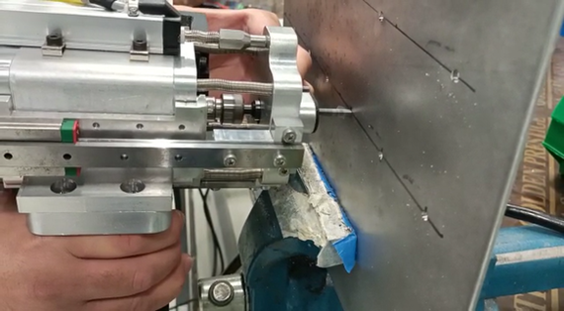
Figure 1. The refined deburring end-effector during manual testing in STRATA’s facility.
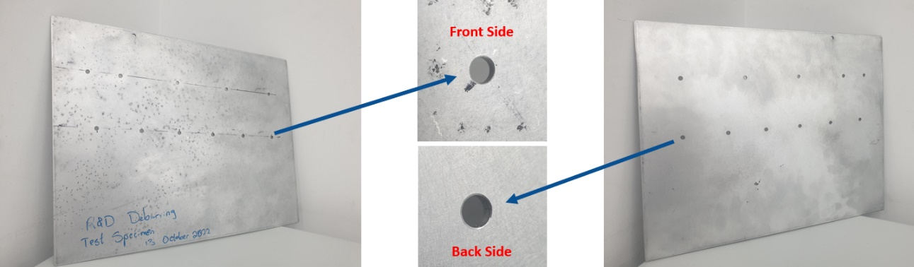
Figure 2. Deburring results using our refined deburring end-effector
- The deburring results meets the required specifications at STRATA. Additionally, using this tool on our manipulator further enhances the deburring process in terms of precision and repeatability.
- Following the validation of the deburring end-effector, we have conducted automated deburring tests in our facility. These automated tests can be seen in this video: https://kuacae.sharepoint.com/:v:/s/IntelligentRoboticManufacturing/EeqE5XZTzrhBlP7vWaXrgOgB3ePgtU_uPx9zo_XSISv93A?e=ifdCmA.

  - Mobile Robot Upgrade:
- We have enhanced the mobile robot’s internal wiring and piping system by:
    - Embedded all the systems’ pneumatic parts to be inside the UR10 control box and performed all the machining works related to this process.
    - Enhance the internal cable and pipe management system by adding a system of cable trunks to facilitate the maintenance and development works.
    - Add an automatic cooling and ventilation system to enhance the performance of the internal electronic parts.

    - KPI summary:
  - Industrial prototype for deburring is currently under testing and evaluation.
  - The painting end-effector is still under-development for industrial use, and is slightly delayed due to late delivery of required equipment.
  - We are finalizing the upgrade of the mobile robot for STRATA
  - One article for the full multi-application system is in progress.

- For the Counter-Sink Inspection Task:
  - CSK inspection with conventional cameras:
- We are still working with STRATA’s R&D team to integrate this capability on their robot using conventional vision.

  - CSK inspection with neuromorphic cameras:
- After demonstrating robust detection of the countersinks by the neuromorphic vision sensors using the event-based circle detection and warping of events, we have proceeded to prepare the experimental setup. The experimental setup will utilize the KUKA KR 30 for its speed and precision, the IDS Ueye Camera as a frame-based sensor, prophesee as the neuromorphic vision sensor, and the Intel NUC as the onboard processor. The experimental hardware is shown below:
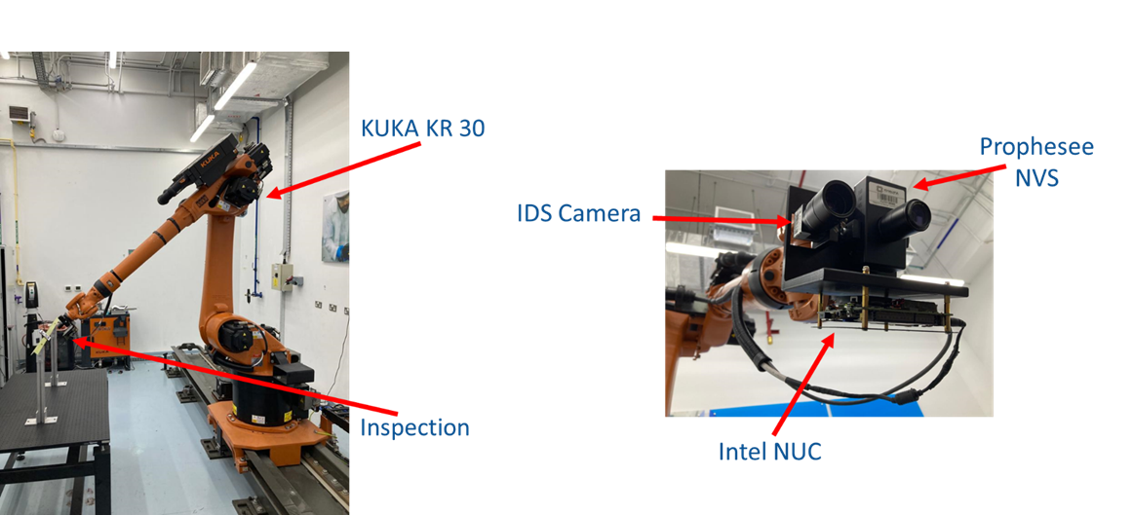
Figure 3. Experimental setup of the countersink inspection by the neuromorphic vision sensor.
- Having the experimental setup ready, the cameras need to be intrinsically and extrinsically calibrated for controlling their motion during the fast scan of the countersinks. While this is feasible for the frame-based sensor, not much work has been in the state-of-the-art regarding fiducial markers detection using a neuromorphic vision. To circumvent this, we converted events to grayscale frames in real time, where the Aruco markers can be detected using conventional computer vision, see figure 4.
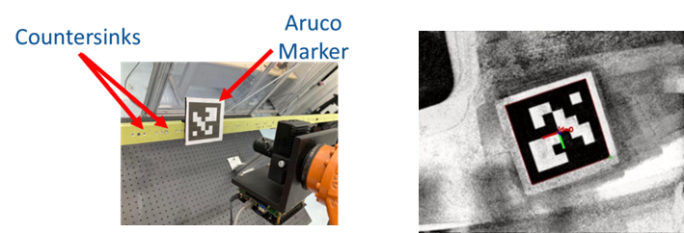
Figure 4. Aruco marker detection using a neuromorphic vision sensor.
- Currently, the experiments are ready to be conducted such that the results are obtained for the desired publication in Robotics and Computer Integrated Manufacturing Journal.

    - KPI summary:
  - We are currently testing the countersink inspection using conventional camera at STRATA R&D.
  - We are working on an article related to countersink inspection using neuromorphic vision.

- For the vision based tactile sensor:
  - We have submitted our article titled: “A Novel Vision-based Multi-functional Sensor for Normality and Position Measurements in Precise Robotic Manufacturing” to the “journal of intelligent manufacturing” (IF: 6.485) showing the superior results of our novel multi-functional vision-based sensor for robotic guidance and tactile sensing. The paper video can be accessed at: A Novel Vision-based Multi-functional Sensor for Normality and Position Measurements in Precise Robotic Manufacturing.mp4 - Google Drive

  - We are currently finalizing a second article titled: “Elastomer-based Visuotactile Sensor for Normality of Robotic Manufacturing System” that details the FEA simulation of our visuotactile sensor to create a digital twin. The article will be submitted to the MDPI Polymers journal during the first week of November.

    - KPI summary:
  - An article on the visuotactile sensor for robotic deburring has been submitted.
  - A second article on the material properties and the corresponding FEA simulations of visuitactile sensors is in final stages of compilation.

- For the robotic blade sorting project (with SANAD):
  - The perception subsystem is still under testing and further development and enhancement:
- The perception subsystem is modified and runs on two stages (two-stage detection) for both blades, boxes, and slots; 1st stage from a vantage point, and 2nd stage at close proximity.
- The first stage detection and localization of blades is already done, where it utilizes Convolutional Neural Network. A new dataset was collected for training purposes in order to enhance the detection and localization of the blades and their corresponding centers where experiments have shown that any error in center localization will cause gripping error and hence insertion error.
- The new dataset collection was automated through our robotic sorting platform. Where the camera used to record the video was the Intel D435, which is used in our perception system (which has proven a better detection compared to manual collected dataset by a different recording device with different resolution and specs), additionally, we generalized the new dataset, to include different background color and texture, different lighting conditions, and different depth from target; 5000 frames where collected, 500 of which has been labeled to train the network, where at a later stage the rest will be included.
- The second stage detection is under development where it will re-localize the blades when in close proximity (before the gripping action); the second stage detection will also utilize Convolutional Neural Network, the current approach is to use the “YOLO” Network model and benchmark. The vision algorithm will be modified to adopt the changes.
- The 1st stage of sorting algorithm is finalized and the load cell is already integrated in our system, where the system will approach each blade, grip it, lift it, record its weight, and return it to its slot. After recording all blades weight the system will generate sorting sequence (high to low). At later stage (after consulting with Sanad’s R&D team) the system will generate the final sorting/installation sequence according to Sanad’s sorting/installation protocols.
- The overall mission planner (Version 1) of the system will be modified (after consultation with Sanad’s R&D), where:
  - The system will execute the weighing process and return the installation/sorting sequence
  - The system (Version 0) was programmed to do the sorting in a new box, whereas now it will generate an installation sequence report without doing the actual sorting. The installation sequence will guide the workers during installation of blades on the rotor.
  - According to the new needs the mission planner will be re-programmed to adopt Sanad’s new requirements/approach, the fiducial markers will be used to map all the blade’s locations with the corresponding slots and generate the installation sequence report.
- We conducted multiple experiments to test the system, where it shows a promising initial results, still we are experiencing some challenges that we need to overcome in the next development stage. Attached two video, one showing the system in action with successful weighing task completion and the other with insertion error of one blade due to the aforementioned challenges in the report.
- More effort will be directed towards development on the perception & manipulation in terms of gripping/weighing/releasing the blades and error-free insertion in the corresponding slots.
- Another important bottleneck that will be investigated later is the gripper calibration. Where after installing the gripper it need to be calibrated in relation to the robot flange to avoid any gripping error. A calibration routine will be also be supplied.
- At a later stage, the repeatability and precision of the system will be evaluated, such as the load cell readings and system’s success rate in completion the weighing task without any errors.
  - Links for some of the results (videos):
- Video1: https://kuacae.sharepoint.com/:v:/s/IntelligentRoboticManufacturing/EUzJbbLBmuhCu83k9gZ4rFkBuzqUXEdPmSF4RjxE_ZdbVw?e=THoCzH
- Video2: https://kuacae.sharepoint.com/:v:/s/IntelligentRoboticManufacturing/EQmiayxfDEZHi8Ds9A10QxcB8teKm_TRB-A6WAJ5hxhPQg?e=U6Uj3Y
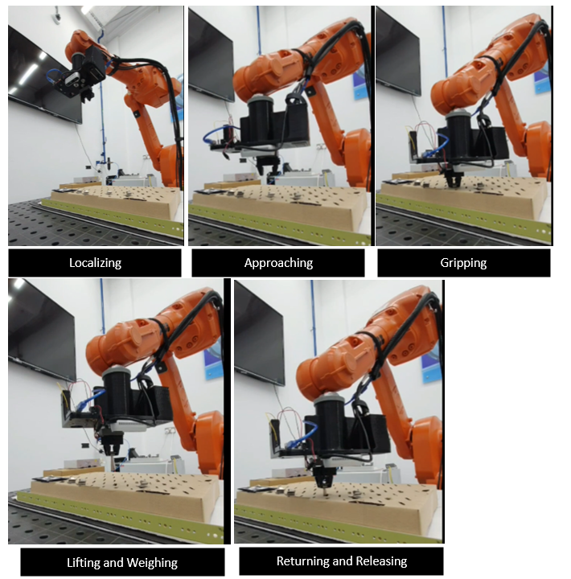
Figure 5. The different stages of the robotic blade sorting process.
    - KPI summary:
  - In progress to develop industrial prototype for SANAD Aerotech.
  - Upcoming article on the overall system design and integration of visual guidance algorithms in the sorting pipeline to be submitted by end of 2022.

- For the automated blade inspection (with SANAD):
  - The current progress of blades chord measurement is as follows:
- The used laser profiler (ScanControl 29xx-100) range is insufficient to scan the entire blade width. So, Seven scan phases are conducted to acquire the blade’s lateral profiles as illustrated in Figure 6.
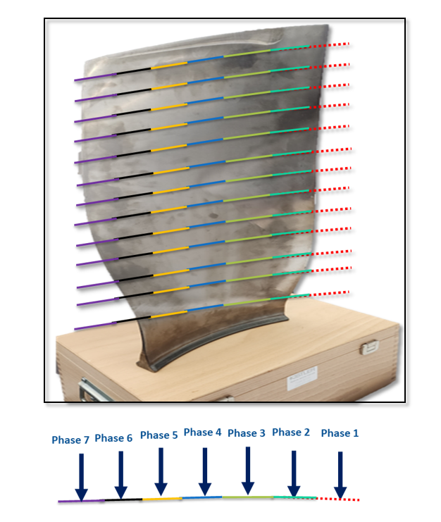
Figure 6. Measurement Methodology
- Only translation in the direction of x-axis, y-axis and z-axis is considered during this experiment.
- Figure 7 shows measured profiles of the blade’s lower half region.
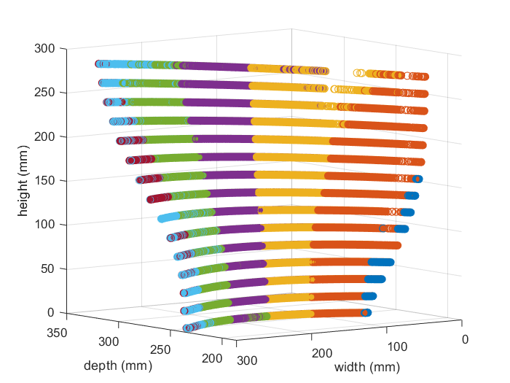
Figure 7. The laser profiles of the scanned blade.
- It can be observed that, as the height increases, we start missing some points of the laser profile. This issue could be fixed by adjusting the scanner's orientation along the z-axis according to the change in blade topology.
- The future work will include calibrating the laser scanner (finding the transformation between the scanner frame and the robot flange frame) which allow us to accurately acquire the blade profiles considering both translation and rotation of the laser profiler.
- Also, the repeatability and accuracy of the measurements will be investigated.
- Video of the conducted experiments: https://kuacae.sharepoint.com/:v:/s/IntelligentRoboticManufacturing/ERdH2V6ZCvxJoClt7xewxdUBOAmOQsKhkNdIOwCKBUzMGQ?e=BdyS5o

  - For AI-based visual inspection of blades:
- We have obtained promising results for the detection and localization of surface defects in blades using anomaly detection from regular rgb images. Prelimenary results can be seen in figure 8 below:
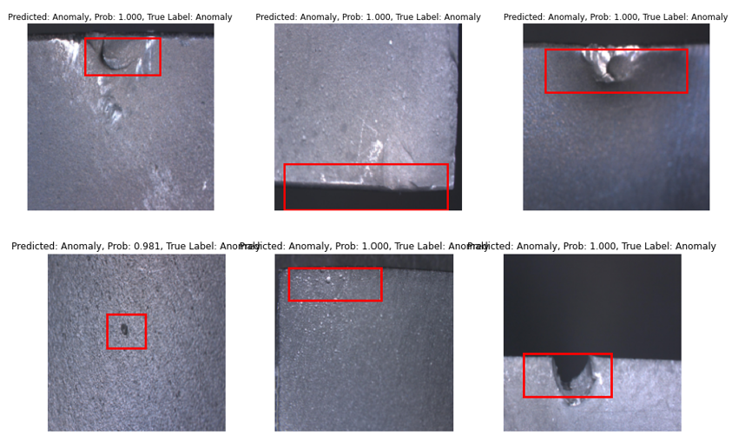
Figure 8. Preliminary results for surface defect detection in blades.
Gantt Chart
Work Package | Month
 | 1 | 2 | 3 | 4 | 5 | 6 | 7 | 8 | 9 | 10 | 11 | 12
The modification and upgrade of the deburring end-effector.
The development of the painting end-effector
Counter-Sink inspection using: a) camera. b) laser profiler
Neobotix MMO-500 preparation for qualification
Vision Based Tactile Sensing for normality control
Vision Based Tactile Sensing for force/torque estimation and regulation
Vision based navigation of mobile robot
Project Closure and recommendations

